Online ISSN: 2367-5357

Title of the Paper – Clear, Descriptive not Too Long and Written without Any Abbreviations (28pt Times New Roman, Bold, Left)

Name of the author (only first letter), family name (in full) (12pt Times New Roman, bold, right)

Key Words: Please leave an empty paragraph after the authors’ names and write your key words (3-6 words) – Key word one with uppercase first letter; key word two with lowercase first letter; key word three with lowercase first letter, etc. (9pt Times New Roman, italic, justified).

Abstract. An abstract of no more than 200 words should state the purposes of the study, procedures, findings and conclusions (9pt Times New Roman, italic, justified).

1. Introduction (14pt, bold, left)

This is a sample of the format of your paper. Please use this template for your paper.
Manuscripts should be written in English. Authors whose native language is not English are strongly advised to have their manuscripts proofread by an English-speaking colleague prior to submission.
Main body text should be 10pt size Times New Roman in two columns, justify. Please, leave empty line between separate paragraphs.
The Introduction should describe the purpose and the contribution of the paper.

2. Section (14pt, bold, left)
The heading of each section should be typed in Times New Roman 14pt, left, bold.
2.1. Subsection (12pt, bold, left)
The heading of each subsection should be typed in Times New Roman 12pt, left, bold.
2.1.1. Sub-subsection (10pt, bold, left)
The heading of each sub-subsection should be typed in Times New Roman 10pt, left, bold.
Formulae
All symbols should be italic. Subscripts and superscripts should be clear and not too small. Give the meaning of all symbols immediately after the equation in which they are used for the first time. Greek and other non-Latin letters and symbols should be explained in the first place where they appear. Take special care to show clearly the difference between digit zero (0) and the letter O, and between digit one (1) and the letter l. Equations should be numbered consecutively with Arabic numbers. The number should be in parentheses at the left according to the page margin. In general, only equations explicitly referred into the text need to be numbered. Citations in the text should be with parentheses. SI units should be used.
(1),, .
(2).
Illustrations, Tables and Figures

Electronic version in EPS (Encapsulated Postscript) is preferred for illustrations. Photos must be glossy prints, of good contrast and reasonable size (no larger than 22x28 cm). Hardcopy of illustrations should be sharp and of good contrast.
Tables should be numbered (with Arabic numbers) consecutively following the order of their first citation in the text.
Figures should be prepared professionally and with high contrast. All illustrations should be numbered consecutively. The amount of lettering on a drawing should be reduced as far as possible by transferring information to the legend. Figures with their captions are included in the text at the correct place and receive Arabic numbers, which should appear in the text.
Tables and figures should be referred to in the text as follows: table 1, figure 1, using italic typeface.

Examples

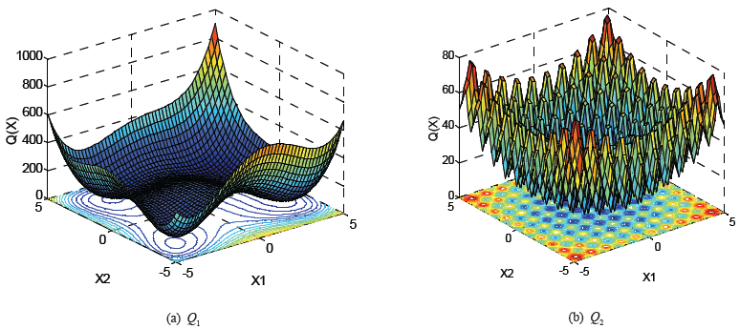

Figure 1. (Times New Roman 10Pt bold) Caption under figure (Times New Roman 9Pt)

Table 1. (Times New Roman 10Pt bold) Caption over table (Times New Roman 9Pt)

 | GDA |  | COA(Logistic) + GDA |  | COA(Cubic) + GDA |  | COA(Sine) + GDA
 | Q* | Success  , % | Q* | Success,  % | Q* | Success,  % | Q* | Success,  %
Q1 (x) | 2.25 ×10−7 | 56 | 2.07 × 10−7 | 100 | 3.22 ×10−7 | 100 | 3.50 ×10−7 | 100
Q2 (x) | 4.64 × 10−4 | 9 | 4.37 × 10−4 | 100 | 4.18 ×10−4 | 100 | 4.46 ×10−4 | 96
Q3 (x) | 8.04 ×10−7 | 48 | 1.55 ×10−6 | 100 | 1.80 ×10−6 | 100 | 1.37 ×10−6 | 100
Averaged success: 37.7 |  |  | 100 |  | 100 |  | 98.7

Conclusion (14pt, bold, left)
A Conclusion section should summarize the main results, advantages, limitations and possible applications.
This section should be typed in character size 10pt Times New Roman, justified.
Acknowledgements (14pt, bold, left)
This section should be typed in character size 10pt Times New Roman, justified.
References (14pt, bold, left)
All publications cited in the text should be presented in a list of references following the text of the manuscript. The references should be listed with Arabic numbers.
Citations in the paper should be with square brackets [1, 5, 10-13].
In the case of references published in any language other than English, the whole bibliographic record has to be translated in English and a notation such as (in Bulgarian) or (in Greek with English abstract) should be added in brackets after the translated text.
Work accepted for publication but not yet published should be referred to as (in Press).
Main reference text should be 9pt size Times New Roman in two columns, justify.
Reference Examples
Periodicals
- Yang, D. X., G. Li, G. D. Cheng. On the Efficiency of Chaos Optimization Algorithms for Global Optimization. – Chaos, Solitons and Fractals, 34, 2007, No. 4, 1366–1375.

Books

- Peitgen, H., H. Jurgens, D. Saupe. Chaos and Fractals. Berlin, Springer-Verlag, 1992, 929.

Conferences, symposia, workshops

- Nielsen, T. Limitation of the Load Regulating Ability of Water Power Plants. 10^{-th} International Meeting of the Work Group on the Behaviour of Hydraulic Machinery under Steady Oscillatory Conditions, Trondheim, Norway, 26-28 June 2001.
- Mansoor, S. Modelling of a Multiple Pump-Storage Units to a Power System. Conference Proceeding PREP’99, Manchester, England, 5-7 January 1999, 412–415.

Manuscript received on 02.11.2017 (10pt Times New Roman, bold).
Short CV, Photos and Contacts
of All Authors

Authors of accepted manuscripts are required to provide short CV (not exceeding 100 words), photos and contacts of all authors.
This section should be typed in character size 9pt Times New Roman, italic, justified.
The photos of the authors should not be larger than 3.3x4.2 cm.
Contacts should be typed in character size 9pt Times New Roman, italic, right.
Example
Place here a photo of the author. Name and family name (in full, bold), PhD, is currently working as an Assistant Professor in the Department of Automatics at University of Chemical Technology and Metallurgy. She received her MSc and PhD degrees in Automation of Industrial Processes from the University of Chemical Technology and Metallurgy, Sofia, Bulgaria. Her main research interests include: applied statistics; identification and system parameter estimation; simulation and modeling of processes and systems; linear and nonlinear control systems and dynamical system approximation.
Contacts:
Department
University or institute
Address, Sofia, Bulgaria
e-mail:

